MANAGEMENT OF HAZARDOUS WASTE AT LSHTM

Everyone who produces hazardous waste has a responsibility to ensure that it is disposed of safely. Hazardous waste must be disposed of promptly by authorized routes. It must not be allowed to accumulate.

This document sets out the procedures to identify, segregate and dispose of hazardous waste.

For disposal of chemical waste, including solvent waste, and clinical waste please contact the ITD Laboratory Services Manager

For other hazardous wastes, contact the School Safety Advisor

Waste management – key principles of control

Elimination/minimisation: You should first consider whether you can eliminate the production of hazardous waste, for example by using non-hazardous materials in an experimental procedure or neutralizing the hazardous material before disposal. If elimination is not possible, consideration should be given as to how waste production will be minimised, for example by not contaminating non-hazardous materials eg sand with small quantities of hazardous material.

Information, instruction and training: Arrangements for handling and disposal of hazardous chemical and biological waste should be incorporated into your standard operating procedures. You should also ensure that staff and students are given suitable information, instruction and training about waste disposal arrangements.

Segregation: It is important that the various waste streams that may be generated within a workplace are segregated appropriately. This ensures that the hazardous material is disposed of safely and does not cause harm to others and/or the environment. Inappropriate segregation and consequent disposal could result in a breach of the regulations and lead to enforcement action against the School.

Waste should not be allowed to accumulate in the workplace, especially in corridors, stairwells etc. Containers should not be filled to capacity, they should ideally be replaced/emptied when approximately ¾ full and removed to the appropriate bulk storage area.

Waste streams

There are 4 major hazardous waste streams produced within the School:

• Chemical – including solvents;
• Clinical waste;
• Electrical – including computers, laboratory equipment; and
• Radioactive.
Other waste streams that are also classified as hazardous include batteries, fridges and freezers and fluorescent/UV tubes.

Disposal of solvents / chemicals / phenol

Solvents:
These are likely to be flammable and/or toxic. Within each laboratory waste chlorinated and non-chlorinated solvents should be collected into appropriately labelled Winchester bottles. Winchesters should only be filled to 80% capacity before removal to the solvent store.
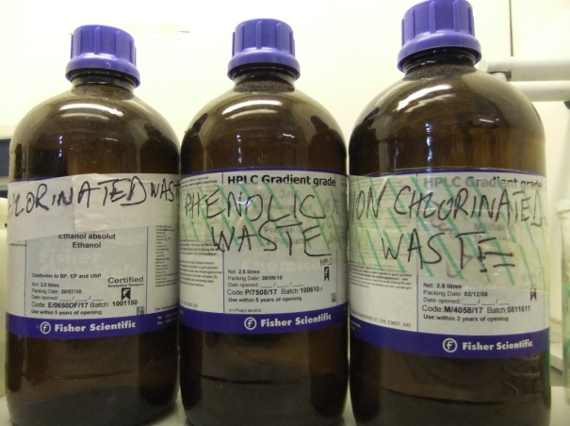
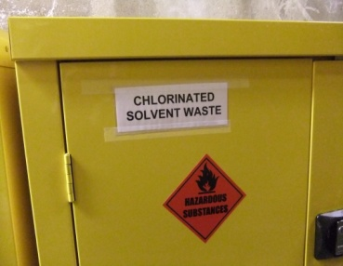
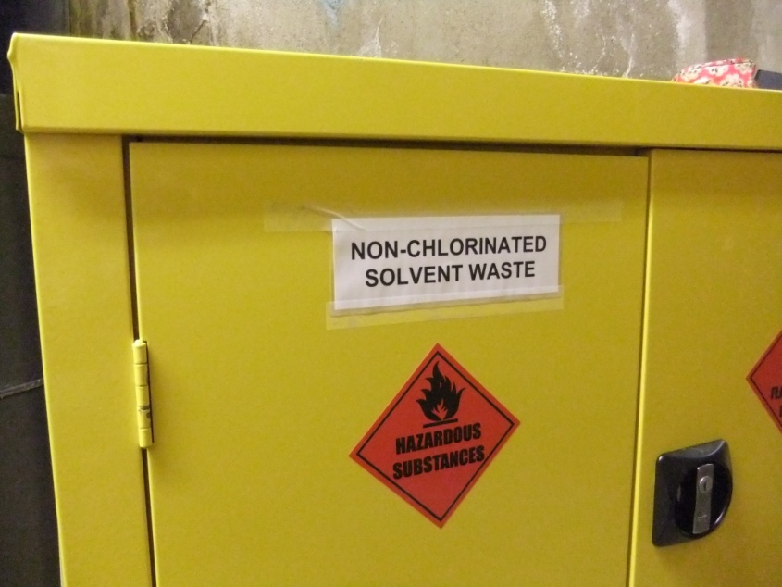
Storage of waste in laboratories Solvent cupboards in solvent store
Organic liquids accepted as Waste Solvents:
Non-chlorinated
- hydrocarbons: alkalines C5-C12, cyclohexane, toluene, xylene
- C1-C3 alcohols, ethylene glycol
- diethyl ether and tetrahydrofuran
- acetone, ethyl and n-butyl acetate

Chlorinated
- C1: dichchloromethane, chloroform, carbon tetrachloride
- C2: trichloroethane, tetrachloroethylene, 1,2-dichloroethane, 1,1,1,-trichloroethane
- C3: 1-chlorobutane plus small amounts of non-chlorinated materials but no water

Solvents for disposal should be securely packaged in a box with a list of the contents taped ot the outside of the box. Winchesters should be labelled and transported appropriately. Contact the ITD Laboratory Services Manager who will send you a hazardous waste disposal form for you to complete. The Winchesters, or other containers of solvent waste, should then be taken to the solvent store in the basement and placed within the appropriate yellow solvent cupboards ready for disposal; a key is available from the ITD Laboratory Services Manager.

Solvent spill kits are available if required within the waste solvent store.

Chemicals:
The majority of chemicals used at LSHTM will need to be disposed of as hazardous waste.

Phenol waste:
Within each laboratory waste phenol should be collected into appropriately labelled Winchester bottles. Winchesters should only be filled to 80% capacity before removal to the chemical waste store.
Small items of plastic-ware containing or contaminated with phenol and phenol/chloroform (microfuge tubes, pipette tips etc.) should be disposed of directly into a suitable waste container for final disposal as chemical waste.

Chemicals and phenol for disposal should be securely packaged in a box with a list of the contents taped to the outside of the box. Winchesters should be labelled and transported appropriately. Contact the ITD Laboratory Services Manager who will send you a hazardous waste disposal form for you to complete. The box/Winchester should then be taken to the chemical waste store in the yard; a key is available from the ITD Laboratory Services Manager.

Where the contents of containers are unknown, for example, unlabelled containers discovered during laboratory clean-ups, this should be made known to the ITD Laboratory Services Manager so that arrangements can be made for appropriate disposal.

Radioactive waste

LSHTM has authorisation from the Environment Agency to dispose of radioactive material, a copy of this can be found on the intranet.

Specific details of which isotope and its permitted level of usage can be found on the door of each radiation supervised laboratory.

Further information is available from the Radiation Protection Supervisor

Sharp waste
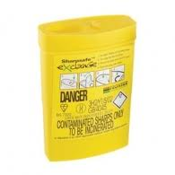
- Category 2 contaminated sharps
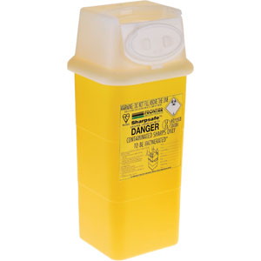
This includes syringes, needles, scalpels, blades, microscope slides and coverslips, glass pipettes and any other sharp instruments. These should be placed in an appropriate sharps container that meets both BS 7320 and is type approved for transport regulations (see below). Please complete the label on the container before putting it into use. Containers should only be filled to ¾ full, sealed, the lab number written on, and taken to the CSU for autoclaving prior to disposal as clinical waste for final incineration.

- Category 3 contaminated sharps
All sharp waste from category 3 laboratories should be autoclaved prior to removal to the clinical waste store for final disposal by incineration

- Broken Glass
Any contaminated hazardous broken glass should be placed into an appropriate sharps bin and autoclaved prior to final disposal as clinical waste by incineration.

Non contaminated broken glass should either be placed in the ‘broken glass’ bins in the laboratory or directly into the large broken glass bins by the goods lift on the second floor.

Gas Canisters
All empty portable gas canisters used for Bunsen burners should be disposed of via the blue bin labelled ‘Gas Canisters’ in the courtyard. Any empty canisters being stored in the laboratory prior to disposal must be stored in an appropriate fire resistant cupboard.

Chloros Containers
All empty Chloros pots should be returned to procurement for recycling.

Laboratory waste

All waste from containment level 2 and containment level 3 laboratories which contain biological agents should be treated to render it non-infectious before final disposal.

All waste to be autoclaved should be placed in appropriate autoclave bags, within autoclave bins. Once the bins are booked onto a run they should be transported to the autoclave. The autoclave bin lids should be securely closed with autoclave tape on with the laboratory number and the date written on the tape - do not overload the bins.

- Containment Level 2 Laboratories
Infectious/potentially infectious material from Containment Level 2 laboratories and associated facilities e.g., all clinical/biological material such blood, other body fluids, excreta and secreta from humans, DNA, anatomical material, cell cultures (including plant cells), contaminated plastic consumables should all be placed into an autoclave bin along with gloves and any other disposable personal protective equipment and taken to autoclave for final decontamination prior to final disposal by domestic incineration.

- Containment level 3 laboratories
All waste from containment level 3 laboratories should be autoclaved for decontamination prior to final disposal by domestic incineration.

Any waste Surfanios must be labelled as such on the autoclave bin before transport to the autoclave and final disposal by incineration.

Within the malaria containment level 3 laboratories non-contaminated waste, such as pipette wrappers, may be placed into autoclave bags and taken directly to the autoclave without the need for an autoclave bin.

- Genetically Modified waste
Any waste arising from activities involving genetically modified organisms/genetically modified micro-organisms (GMOs/GMMs) must be inactivated using a validated means before discharge or disposal; this is a requirement of the GMO (Contained Use) Regulations.
In practice, given that the regulations also require an autoclave to be available for all laboratory activities involving GMMs, autoclaving prior to disposal should be the option of first choice. However, chemical disinfection can also be used. Autoclaved waste is then disposed via domestic incineration.

- Defra waste
All waste arising from activities involving Defra regulated group 2 and group 3 pathogens must be autoclaved prior to removal from the School. Once autoclaved waste should be placed in yellow clinical waste bins and then incinerated as clinical waste as soon as it is practicable. A record of the autoclave trail and final disposal route must be kept. (See Appendix 1)

- Large quantities of hazardous waste for disposal
Any clinical waste that cannot be autoclaved due to quantity or nature of material, please contact the ITD Laboratory Services Manager for disposal advice. The normal route in this case would likely be direct disposal via clinical incineration.

- Redundant Equipment
Any equipment for disposal should be appropriately decontaminated and placed by the lift, with a completed Laboratory Equipment Disposal Form (see Appendix 2) attached, for removal by the porters. A copy of the completed form should be sent to the ITD Laboratory Services Manager.

Disposal of material covered by the Human Tissue Act

For information on the correct procedure for the disposal of HTA material please contact
the Designated Individual for HTA.

Appendix 1

Defra Waste Disposal Form

Laboratory no...........
Each of the 4 stages for disposal should be documented as detailed below.
- Ensure bins are clearly labelled as defra waste.
Fill in and sign part 1 when you remove the box(es) from the laboratory. The form should then be left next to the autoclave.

- A member of the CSU staff should fill in part 2, recording the autoclave serial number and cycle number, after the waste has been autoclaved and transferred to yellow clinical waste bins.

- The Porter who removes the waste to the clinical waste store in the yard should fill in and sign part 3.

- The Laboratory Services Manager (or designated deputy) will complete and sign part 4, once the waste has been removed from the site by Grundons clinical waste disposal services.

Once completed this form should be filed in the appropriate autoclaving record file located in the CSU (room 209).
- Removal from laboratory:
Date……………………………… Name ……………………………
No of Boxes ……………………. Signature………………………..

- Autoclaving
Date ……………………………. Name…………………………….. Autoclave serial no……………………. Signature…………………………
Autoclave cycle no…………………….

- Removal to clinical waste
Date……………………….. Name…………………………….. Signature…………………………
- Final disposal
Date……………………….. Name…………………………….. Signature…………………………

Appendix 2

LABORATORY EQUIPMENT DISPOSAL
Items for disposal which have been used in laboratories must be certified as safe for disposal before they are removed from the Faculty. An assessment must be made as to the risk of any contamination, and appropriate action taken to decontaminate if necessary. Advice can be sought from the Faculty Safety Supervisor, Laboratory Services Manager, the CL3 Training and Safety Officer, or the Safety Office.

Item for Disposal

Make |  |  |  | Model |  |  |  | Serial  Number
Origin |  |  |  | Contact Person / Tel
Item has been used in areas with possible exposure to:

Hazardous chemicals |  |  | No / Yes (specify)
Radioisotopes |  |  | No / Yes (specify)
Pathogens |  |  | No / Yes (specify)
Other (state) |  |  | No / Yes (specify)
Details of decontamination

Any remaining hazards

Comments/Instructions

This item is certified as being safe for disposal to known laboratory related hazards

Issued by (name)……………………………. Signature …………………………………..

Position ………………………………………. Date ………………………………………..

