The London Cycle September is here!
September 1st – 30th 2017
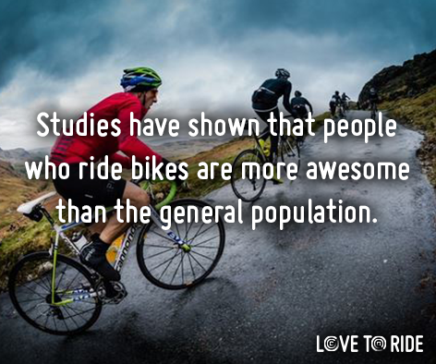
Get ready for the main #YearoftheBike event - Cycle September! Take part in a FUN, FREE, National competition to see which workplaces can earn the most points for riding and encouraging their colleagues. Head to www.lovetoride.net and set yourself up choosing ‘SOAS’ as your workplace / team. A Smoothie Bike session will be taking place on the 5th of September just by the entrance in the main SOAS building, from 11am to 2pm. Drop by for some freshly made smoothie and help with registration.
Organisations of similar sizes will compete against each other to see who can get the most staff to ride a bike between 1-30 September.
The month long event is not about who can ride the most miles (although there will be prizes for the top rider), but who can encourage the most people to give cycling a try.
We'll have plenty of FREEBIES up for grabs for individuals as well as amazing prizes for the winning organisation/department in each size category.
You don't have to be a keen cycle commuter to take part - all types of rides count towards your teams score!
There is an additional internal prize open to everyone who takes part, regardless of the mileage they have achieved, which is a £30 voucher for the best cycling photo taken during the competition.
Submit your entry to d.gadea@bbk.ac.uk who will coordinate the judging panel and share the results at the end of the competition.
There are fantastic additional prizes you could win in the national competition including: bikes, holidays, vouchers and more! In previous Love to Ride events we've had top of the range bikes from brands like Genesis and Raleigh, vacations away to Wales, Cape Corsica, Amsterdam and Copenhagen, Zip lining and jet pack experiences, hot air balloon rides and local spa days... plus many more! See all prizes on the www.lovetoride.net website.

